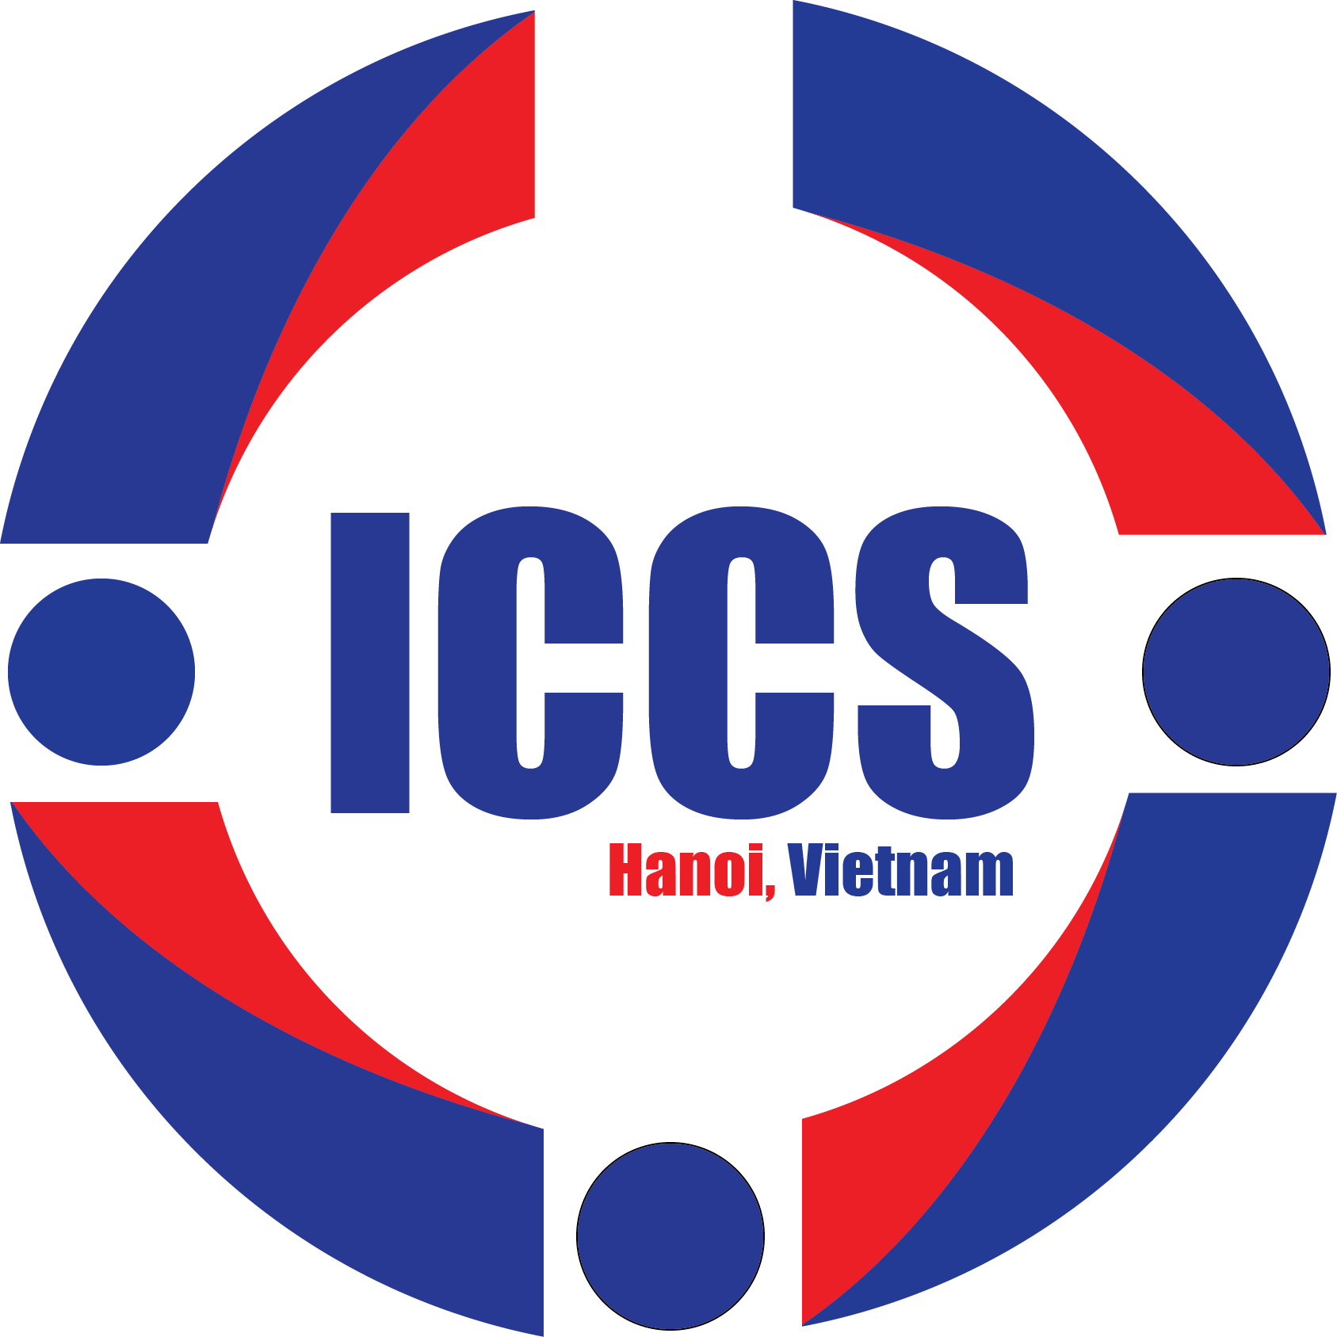
CALL FOR ABSTRACT SUBMISSION
The 1st International Conference on Chemical Sciences – ICCS 2022
December 8-11th, 2022
The International Conference on Chemical Sciences (ICCS) is organized with the aim to facilitate an innovative forum where current progresses in Chemical Sciences are introduced, discussed and debated. To this end, the conference aspires to bring the international chemist community, especially the key contributors of the field, to Vietnam, where chemical science development has been receiving increased attention. ICCS is also expected to be a platform for strongly motivated chemists working in Vietnam to promote the overall level of national chemistry through networking and collaboration.
The first edition, ICCS-2022 will be held in USTH Campus in Hanoi between 8-11 December 2022 with three scientific themes:
- Chemistry for Energy Conversion and Storage;
- Chemistry for Environment Analysis and Treatment;
- Chemistry for Healthcare.
For the success of ICCS – 2022, we greatly appreciate your participation and submission of research abstracts in accordance to the following information:
Important dates:
- Abstract Submission Dates: 01/09/2022 – 30/09/2022
- Submission acceptance notification to authors: 03-07/10/2022
- ICCS 2022 organization date: 08 – 11/12/2022
Abstract guidelines
- Page limit: 01 page
- Formatting: please follow the attached ICCS 2022 formatting guideline.
Submission Site:
Abstract in Microsoft Word (.docx) format must be included as attachment and submitted via email to: iccs2022@usth.edu.vn
ABSTRACT SUBMISSION GUIDELINES

PRESENTATION TITLE (FONT ARIAL, 11 PT, BOLD, CENTER ALIGN, 1.15 LINE SPACING, SPACE BEFORE PARAGRAPH 3 PT, SPACE AFTER PARAGRAPH 0 PT)
Author¹*, Author², Author³* (Presenter name underline) (Font Arial, 9 pt, center align, single line spacing, space before paragraph 12 pt, space after paragraph 0 pt)
¹Author institution…………, Address;
¹Author institution…………, Address;
¹Author institution…………, Address;
Font Arial, italic, 8 pt, center align, single line spacing, space before paragraph 12 pt, space after paragraph 0 pt)
*Email: authoremail@mail.com (Font Arial, 9 pt, center align, single line spacing, space before paragraph 12 pt, space after paragraph 0 pt)
Abstract: (Font Arial, 9 pt, bold, center align, space before paragraph 12 pt, space after paragraph 0 pt)
Abstract content (maximum 300 words, Font Arial, 8 pt, justify align, 1.5 line spacing, space before paragraph 12 pt, space after paragraph 0 pt)
Keyword (Font Arial, 8 pt, bold, left align): Keyword 1, Keyword 2, Keyword 3… (maximum 5 keywords) (Font Arial, italic, 8 pt, justify align, 1.5 line spacing, space before paragraph 12 pt, space after paragraph 0 pt)
Abstract TOC images included (if any)
References (if any)
1. Authors, Journal name (in abbreviations), published year, Volume, page numbers (Font Arial, 8 pt, justify align, single line spacing, space before paragraph 12 pt, space after paragraph 0 pt)

