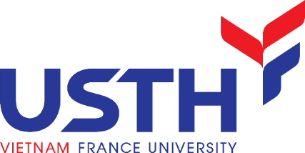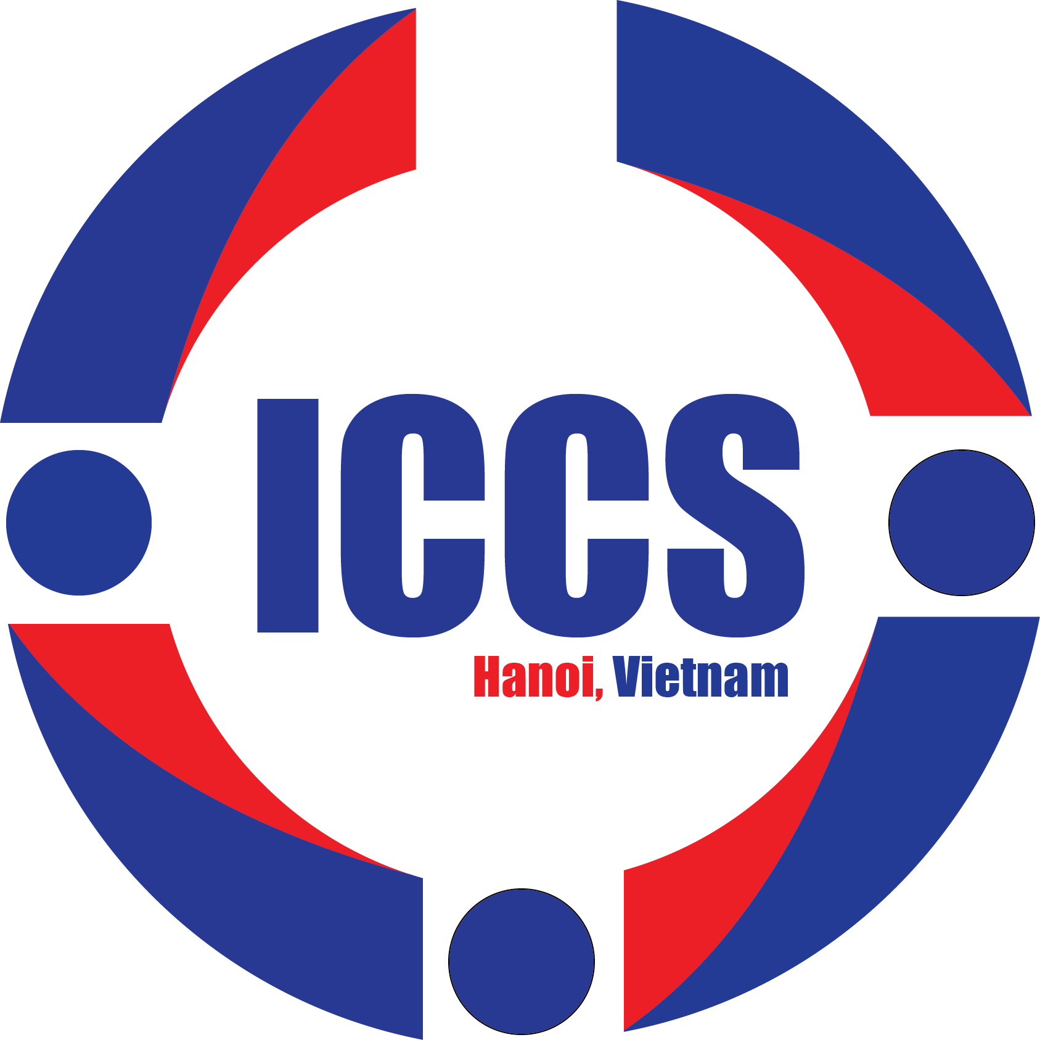
CALL FOR PARTICIPANTS
The 1st International Conference on Chemical Sciences (ICCS 2022)
December 8-11th, 2022
Dear colleagues,
Established on December 9th, 2009 within the framework of the Intergovernmental Agreement between Vietnam and France, the University of Science and Technology of Hanoi (USTH, also called Vietnam France University) is a public international university with ambition to become a research university by 2030.
This year, USTH initiates a series of International Conference on Chemical Sciences (ICCS) with perspectives to bring the international chemist community, especially the key contributors of the field, to Vietnam, where chemical science development has been receiving increased attention. ICCS is also expected to be a platform for strongly motivated chemists working in Vietnam to promote the overall level of national chemistry through networking, collaboration, or (even) seeking mentors for their research.
ICCS will be designed as a biannually conference. The first edition, ICCS-2022 will be held in USTH Campus in Hanoi between 8th - 11th December, 2022. The scientific topics will include: (i) Chemistry for Energy Conversion and Storage; (ii) Chemistry for Environment Analysis and Treatment; (iii) Chemistry for Healthcare. The conference program will include keynotes, invited talks, selected oral presentations, and poster presentations. Participants will also have the opportunity to partly experience the beauty of Vietnam as portrayed by the religious tour to Trang An world heritage area.
Please refer to https://usth.edu.vn/en/ and https://www.facebook.com/iccs2022 for more information or write to iccs2022@usth.edu.vn for any inquiry.
On behalf of the organizing committee, we greatly appreciate your participation and contribution to the success of the ICCS 2022. We would be grateful if you could propagate this information to collaborators, scientists, researchers, and students, who might be interested to join us.
Looking forward to welcoming you to Hanoi this December,
Kind regards,
Assoc. Prof. Dinh Thi Mai Thanh
ICCS 2022 Conference Chair
USTH Rector

